**M2: justify the software, tools, file format, image resolution and colour depth used for creating graphic images.**

**Introduction**

In this assignment, I will be justifying tools; file format; image resolution and colour depth used for graphic images in **Adobe Photoshop CS5**. I will be using different images for each of them to demonstrate the difference.

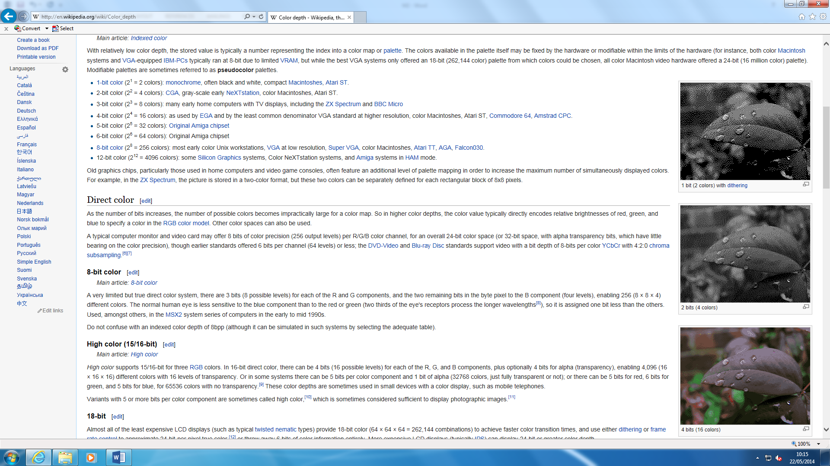

**Colour depth**

Colour depth, also known as bit depth, is either the ‘bit’ used to specify the colour used in a single pixel. The colour depth ranges from 1-bit monochrome to 48-bit deep colour. An image can be present and it can be used to change the colour state e.g. all of the picture would be grey. The depth could be that the ‘grey’ could go ‘light’ or ‘dark’ grey. These are called ‘bits’.

As you can see figure 1.1, it demonstrates the colours that are used on the picture. These range from 1-4 bits and it changes the whole picture by its colour depth. 1 bit is the darkest out of all of them and it goes lighter as the bits increase. Each bit has specific colours that have been inserted. 1 bit has 2 colours. As the bit increases (+1), the colours double. The pattern below shows the how it all works.

* 1 bit = 2 colours
* 2 bit = 4 colours
* 3 bit = 8 colours
* 4 bit = 16 colours

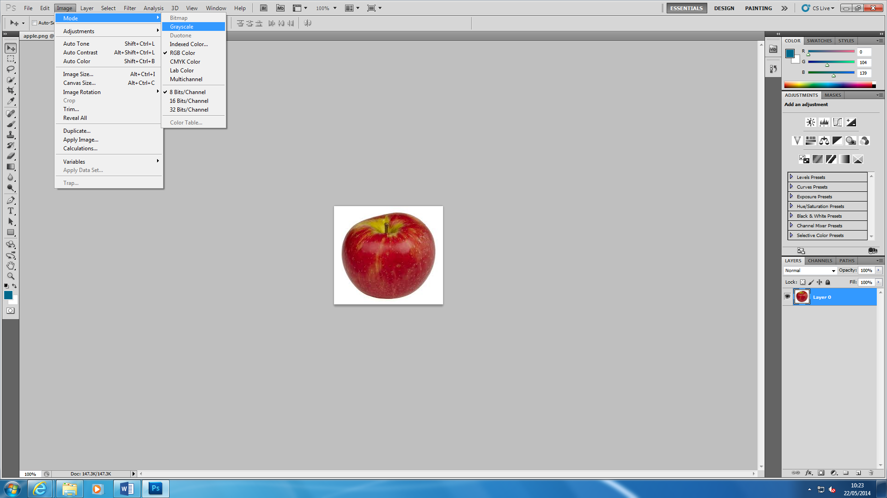

This demonstrates how to change the bits on each image. Each of the image show how many colours you can use. You can ‘Auto Colour’ and it adds more colour to the image. The image below shoes the result of what happens. It detects the bits once you open the image up.

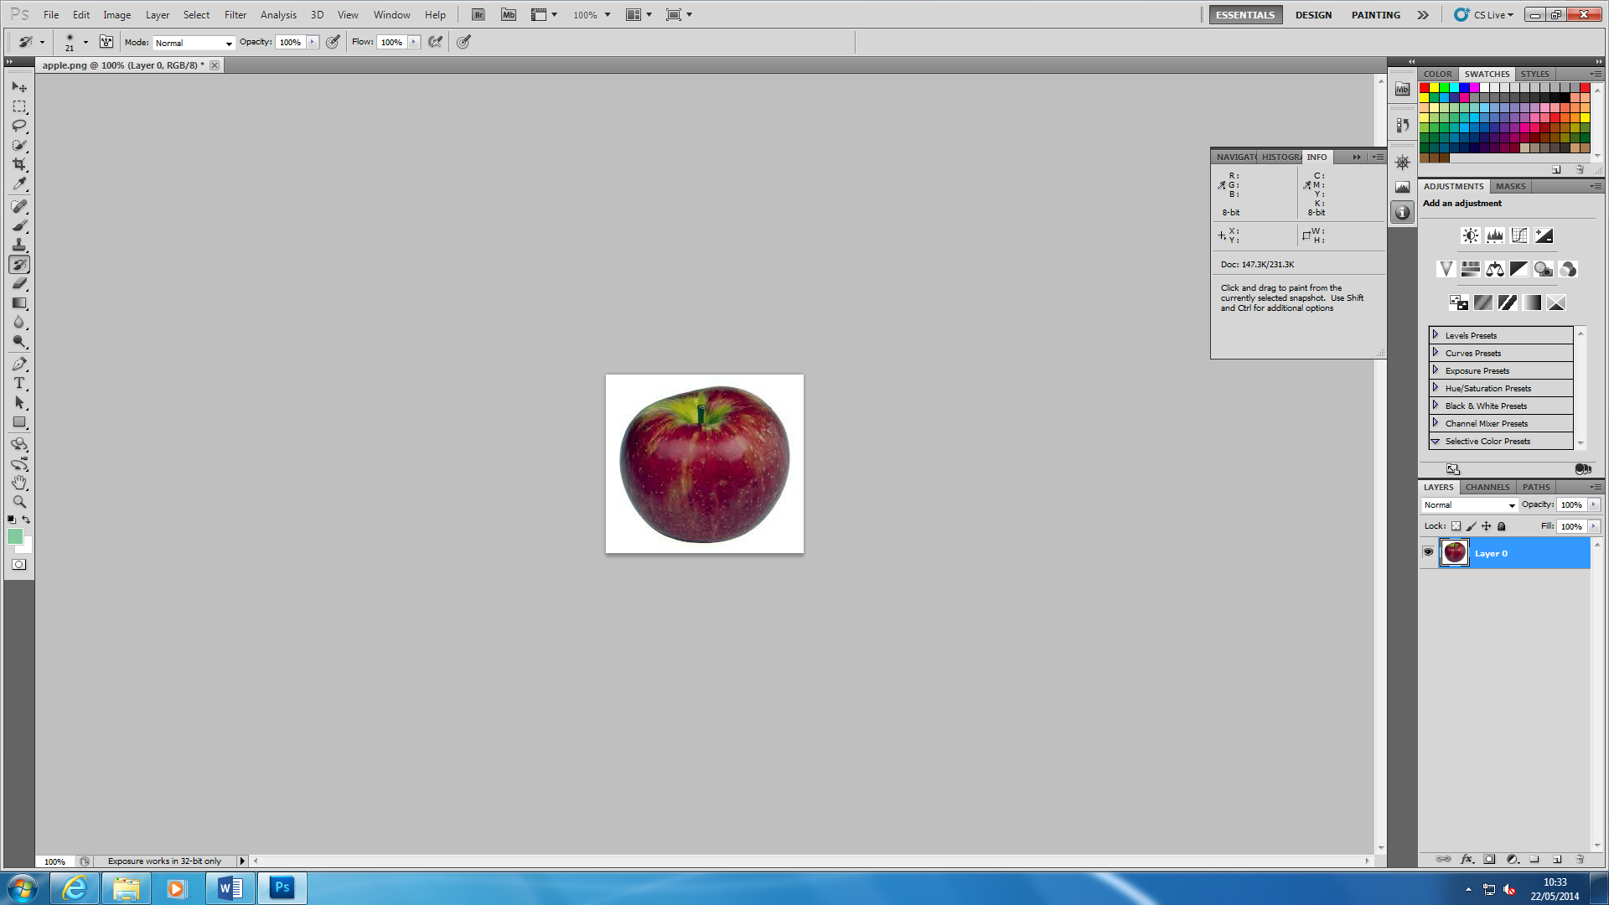

**Image resolution**

Image resolution is the detail the image holds. This means any program can help you resize the image in any shape or form. The user can zoom into the image by following the steps:

**IMAGE 🡪 IMAGE SIZE OR** HOLD THE KEYS **ALT+ CTRL+ I**

By following these steps, you can change the resolution of the image. If you want to change the resolution, it measures it dots per inch (DPI). It is important if you want to change the resolution of the image as you can go into detail, take that picture, and add it somewhere. For example, if you use zoom into a house and you zoom into the window, you can use that for another picture and add it there.

**BEFORE AFTER**

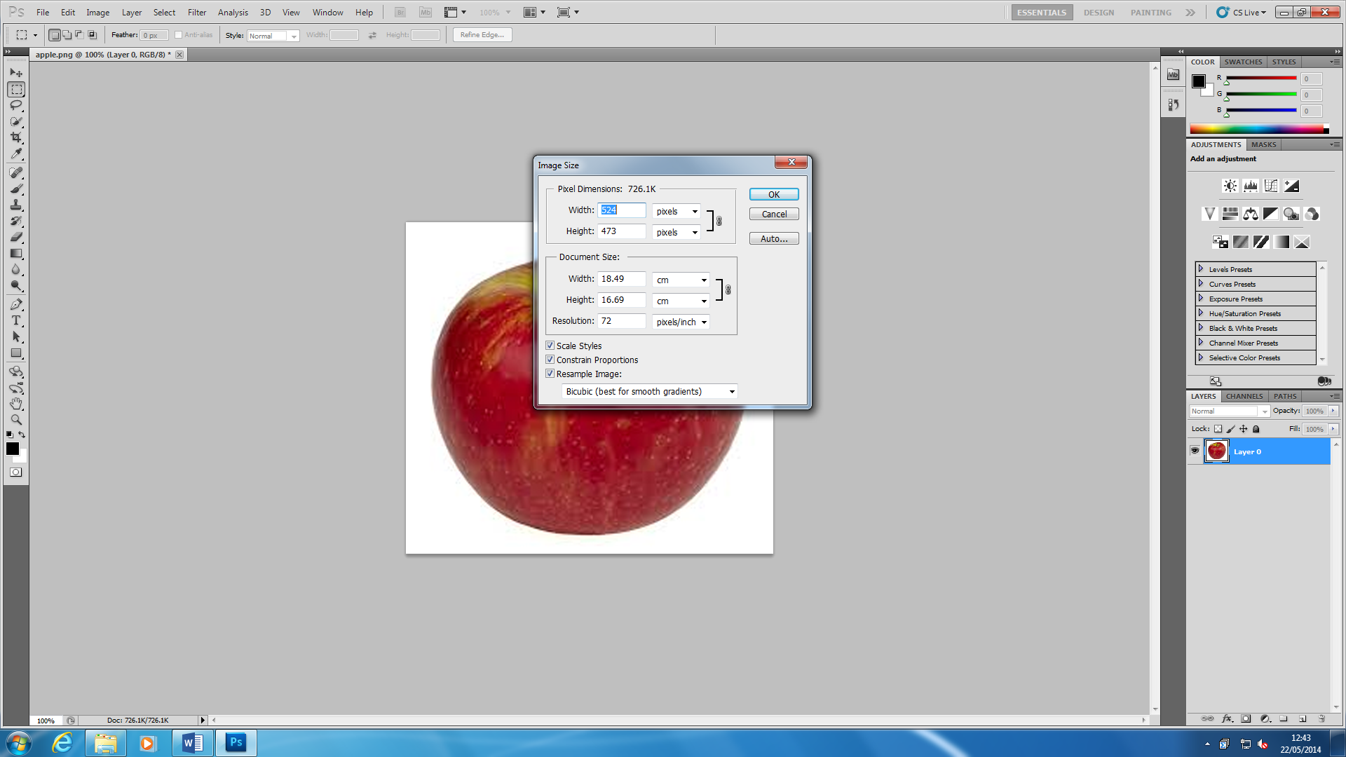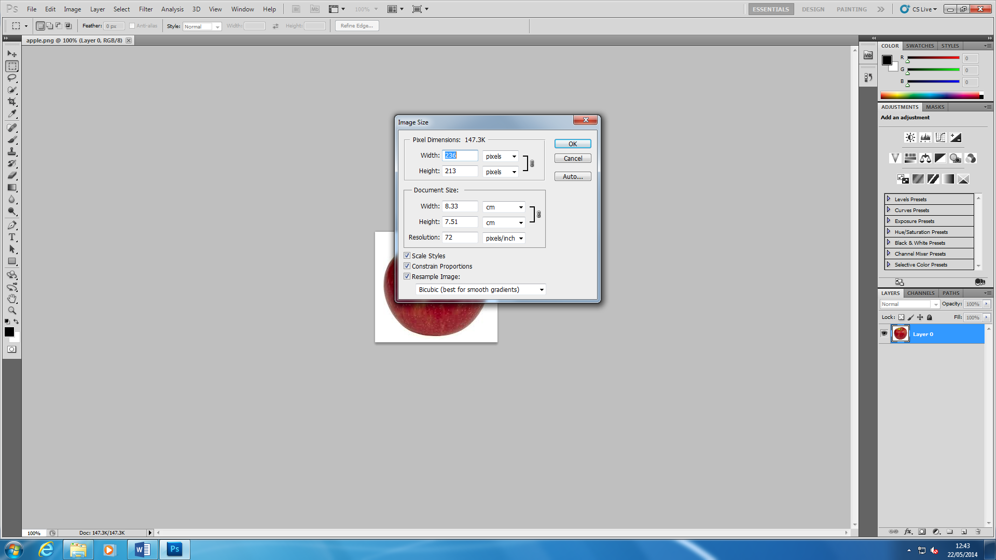

These two images came from Adobe Photoshop and I changed the resolution of the image. ‘Before’ image is all the same. I changed it by typing into the ‘Width’ box ‘524’ to zoom the image. If you really want to zoom right into the image, you can type in a higher number for the image resolution to be high. However, if you do increase the image resolution, the quality of the image loses. The higher the image resolution, the more the quality of the image loses. The image below was the result once I had changed the image resolution.

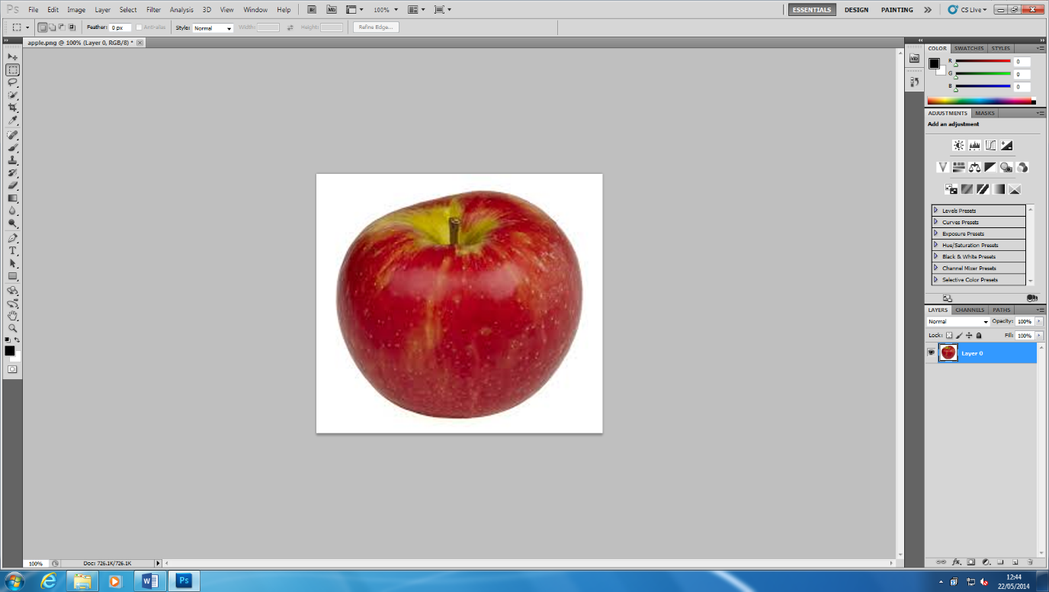

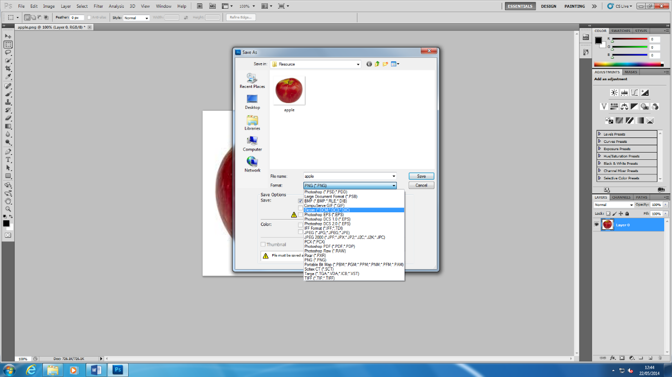**File format**

A file format is a standard code that is encoded for storage in a computer file. Each standard code are different to each other such as BMP, GIF. They are completely different from each other and have different storage available. They are many file formats and the image below shows how many they could be. They could be more but these are a few. As you can see below for Adobe Photoshop, they are many options of how to save the image. It depends how you save it because if you save it on JPEG, it could affect the image. It can make the file compressed, uncompressed or vector format.

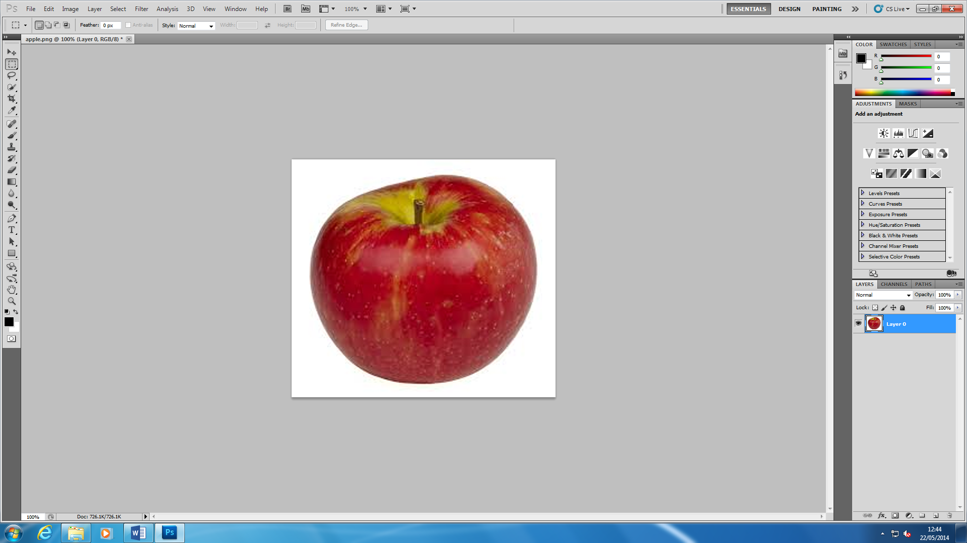

**Tools**

They are various tools that you can use in Photoshop. I am going to name some of the tools that are used such as:

* Rectangle Marquee Tool
* Move Tool
* Polygon Lasso Tool
* Magic Wand Tool
* Crop Tool
* Slice Tool
* Healing Brush Tool

These are some of them, but obviously, they is a long list as you can see the left image.